Assignment-2

Buğra Sarıkaya

17/01/2022

# Part 1:

| location | year | month | day | total_cases | new_cases | total_deaths | new_deaths |
| --- | --- | --- | --- | --- | --- | --- | --- |
| Iceland | 2020 | 11 | 3 | 4957 | 26 | 17 | 5 |
| Lithuania | 2020 | 7 | 26 | 2003 | 7 | 63 | 0 |
| Netherlands | 2020 | 10 | 17 | 225970 | 8149 | 6797 | 32 |
| Romania | 2020 | 4 | 11 | 5990 | 523 | 291 | 21 |
| Iceland | 2020 | 6 | 26 | 1820 | 2 | 10 | 0 |
| Montenegro | 2020 | 5 | 20 | 324 | 0 | 9 | 0 |
| Turkey | 2020 | 7 | 1 | 201098 | 1192 | 5150 | 19 |
| Italy | 2020 | 8 | 16 | 253915 | 477 | 35396 | 4 |
| Denmark | 2020 | 12 | 29 | 159074 | 2640 | 1226 | 22 |
| Vatican | 2020 | 4 | 21 | 9 | 0 | NA | NA |

# P1Q1A:

| location | month | min | Q1 | Q2 | Q3 | max |
| --- | --- | --- | --- | --- | --- | --- |
| Iceland | 11 | 26 | 26.0 | 26.0 | 26.00 | 26 |
| Lithuania | 7 | 6 | 6.0 | 7.0 | 14.00 | 19 |
| Netherlands | 10 | 4028 | 4031.0 | 6090.5 | 8571.50 | 9839 |
| Romania | 4 | 333 | 387.0 | 441.0 | 482.00 | 523 |
| Iceland | 6 | 0 | 0.0 | 0.5 | 1.00 | 2 |
| Montenegro | 5 | 0 | 0.0 | 0.0 | 0.00 | 0 |
| Turkey | 7 | 921 | 1046.5 | 1172.0 | 1182.00 | 1192 |
| Italy | 8 | 477 | 477.0 | 477.0 | 477.00 | 477 |
| Denmark | 12 | 1603 | 1712.5 | 2194.5 | 2688.75 | 2835 |
| Vatican | 4 | 0 | 0.0 | 0.0 | 0.00 | 0 |

# P1Q2A:

| location | max_case | max_death |
| --- | --- | --- |
| Czechia | 11102 | 147 |
| Belgium | 10192 | 283 |
| Austria | 6995 | 113 |
| Croatia | 3955 | 68 |
| Bulgaria | 3614 | 189 |
| Belarus | 1957 | 10 |
| Bosnia and Herzegovina | 1586 | 84 |
| Albania | 836 | 15 |
| Cyprus | 245 | 1 |
| Andorra | 147 | 1 |

# P1Q3A:

| location | month | Mean of dailycases |
| --- | --- | --- |
| United Kingdom | 12 | 43585.00 |
| Italy | 11 | 30548.00 |
| Russia | 12 | 27571.50 |
| Poland | 11 | 24446.20 |
| Turkey | 12 | 19103.00 |
| Germany | 11 | 16841.33 |
| France | 12 | 14451.50 |
| Spain | 8 | 13262.50 |
| Czechia | 10 | 11102.00 |
| Ukraine | 11 | 10908.00 |

# P1Q4A:

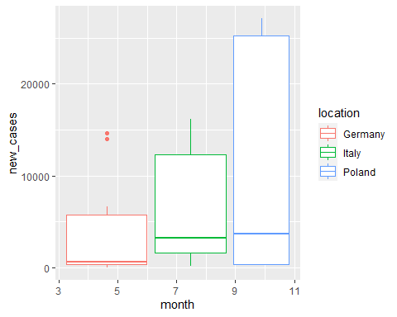

# Part 2:

# P2Q1A:

| x |
| --- |
| The |
| Oak |
| He |
| A |
| Fill |
| Pour |
| To |
| Both |
| Cut |
| Nudge |

# P2Q2A:

## Condition of starting with "a" and ending with "e", is satisfied with these words: are age

# P2Q3A:

## Number of words which have 3 or more vowels is: 1

# P2Q4A:

| wrods | count |
| --- | --- |
| whistling | 9 |
| treadmill | 9 |
| doorknob | 8 |
| gathered | 8 |
| lanterns | 8 |

# P2Q5A:

## age, any, day, exp, her, pro, the words were found in these words: There Either the gathered their many there lathe her then these here farther age